ACH SET UP IN NETSUITE
NetSuite is integrated with Coastal Software & Consulting, Inc. to allow the transfer of payment funds.
To activate ACH Vendor Payments:
- Go to Setup -> Company -> Setup Tasks -> Enable Features (Administrator). Click the Transactions subtab.
- Check the ACH Vendor Payments box.
- Click Save.
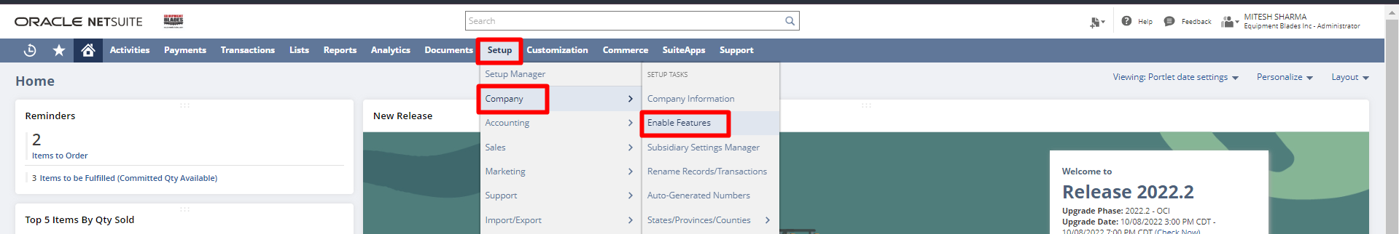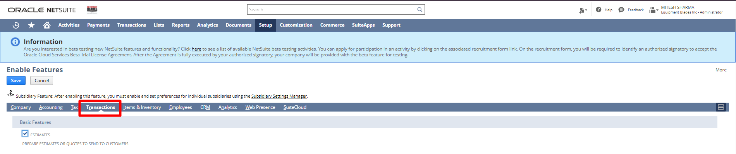
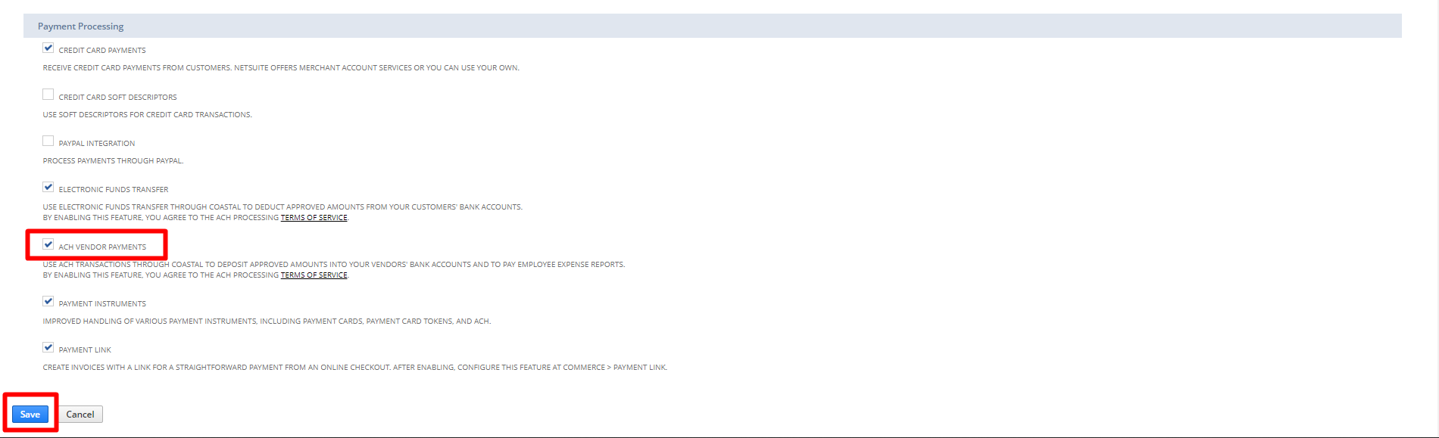
When you activate the ACH Vendor Payments feature, you must apply to Coastal Software & Consulting, Inc. for an ACH processing account
After your ACH account is established, you must set up your company bank accounts for use with ACH Vendor Payment processing.

To set up company accounts for ACH Vendor Payment transactions:
- Go to Setup -> Accounting -> Setup Tasks -> ACH Processing (Administrator).
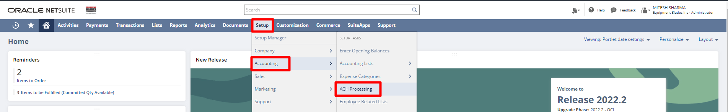
- Click the Company subtab.
- If you have not yet entered it, enter the 6-character company ID number you received from Coastal in the ACH Company ID box.
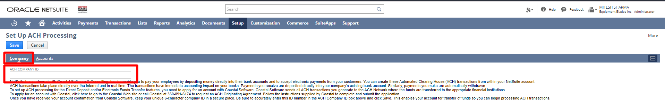
- Click the Accounts subtab.
- In the Use ACH column, check the box next to the bank accounts you will use with ACH Vendor Payments.
For example, mark the checking account to receive payments from customers into the company checking account.
- For each account you mark, enter the following:
  - Bank Name – Enter the name of the bank.
  - Bank Routing Number – Enter the 9-digit routing number.
  - Bank Account Number – Enter the account number, up to 20 digits.
  - Maximum Amount Per Transaction – Enter the dollar amount limit per transaction with this account.
  - ACH Message – Enter a text message to include with all ACH transmissions using this account.
- Click Save.
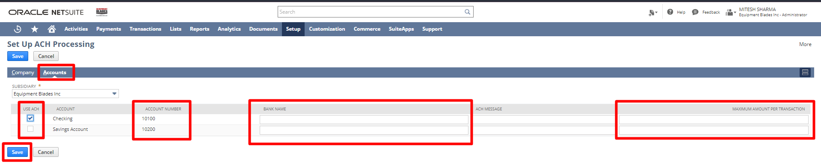

Now, you can transfer funds to vendors' bank accounts when you process bill payments.
To set up vendor records for ACH payment:
- Go to Lists -> Relationships -> Vendors (Administrator).
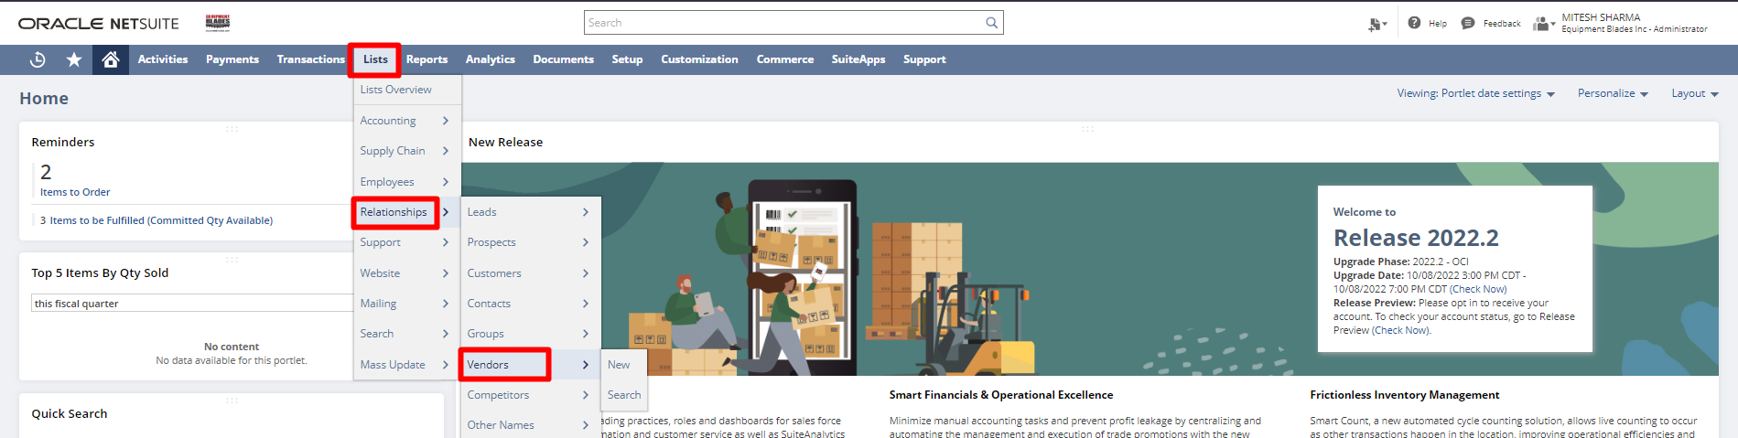
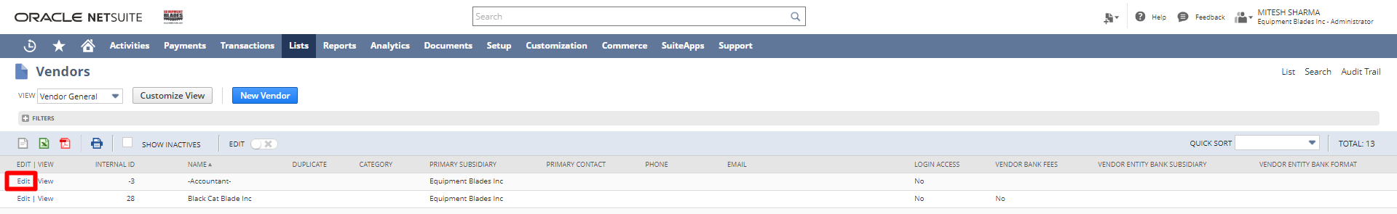
- Click Edit next to the vendor you want to set up for ACH payments.
- On the vendor record, click the Financial subtab, and then click the ACH subtab.
- On the ACH subtab, do the following for each bank account you want to keep on this vendor record:
  - In the Bank Name column, enter the name of the vendor's bank.
You can enter up to 31 characters in this field.
  - In the Routing Number column, enter the 9-digit routing number for the vendor's bank account.
  - In the Account Number column, enter the vendor's bank account number.
You can enter up to 20 characters in this field.
  - In the Limit field, enter the maximum amount of the payment to be deposited to this bank account.
  - Check the Savings Account box if this is a savings account.
  - In the Addenda field, enter identifying text to send to the vendor along with the electronic payment.
For example, you can enter ACH Payment from Wolfe Electronics, Inc.
  - Check the Include Transaction in Addenda box if you want this transaction's addenda to include related transaction number references.
  - Check the Inactive box if you want to keep the account information on file, but not process transactions through the account.
  - Click Add to save the bank account on the vendor record.

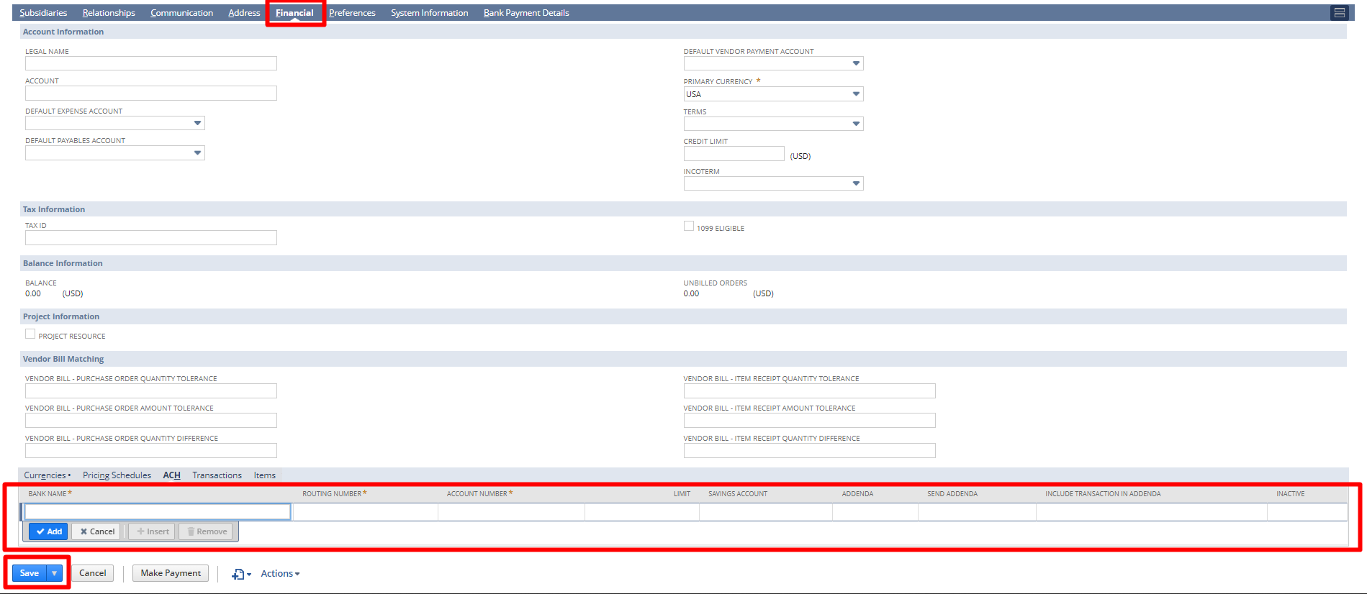
- If you have finished adding the vendor’s bank account information for ACH processing, click Save.
Now, this vendor can be paid using ACH Vendor Payments by navigating to Transactions -> Payables -> Pay single vendor (Administrator).
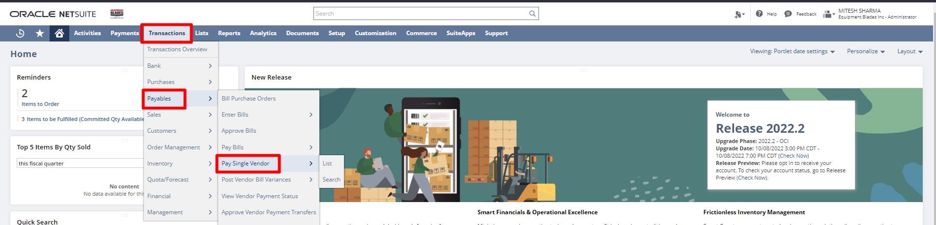
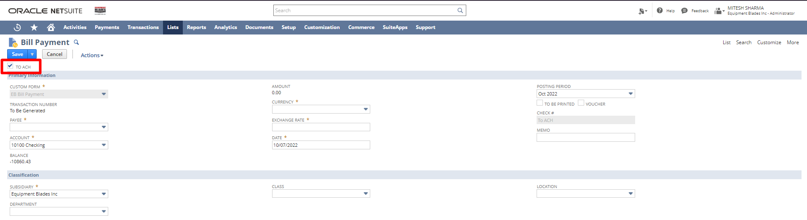

Signature: ________________________________
Date: _____________________________________

Disclaimer:
Upon signing off on the process flow document, you are confirming that the process has been set up per the SOW within NetSuite per your business's needs. Any changes or modifications requested after sign-off will need to be a "change request" at an additional fee.

*** PLEASE ensure that you have logged into NetSuite and tested the process prior to signing off on the setup. Paapri requires sign-off on this document prior to moving forward with any additional design meetings.

